LAB EXPERIMENTS
(Use Case Diagram)

1. Library Management System
Aim:
To model the interactions between Student and Librarian for searching, issuing, and returning books in a Library Management System.
Algorithm:
- Start
- Student searches for a book.
- System checks book availability.
- Librarian issues the book if available.
- Student returns the book after use.
- Librarian updates the system records.
- Stop.
Input:
Student details, Book ID, Search request, Issue/Return request.
Output:
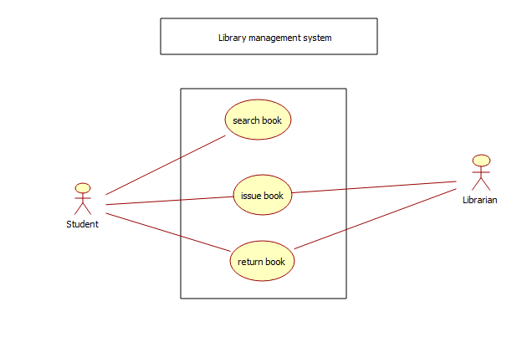
Result:
The Use Case Diagram shows interaction between Student, Librarian, and Library System for managing books.

2. Online Shopping / E-Commerce System
Aim:
To represent interactions between User and Vendor in an Online Shopping System using a Use Case Diagram.
Algorithm:
- Start
- User searches or selects product.
- User adds product to cart.
- User proceeds to checkout.
- User completes payment.
- Vendor processes the order.
- Stop.
Input:
User login details, Product selection, Cart details, Payment information.
Output:
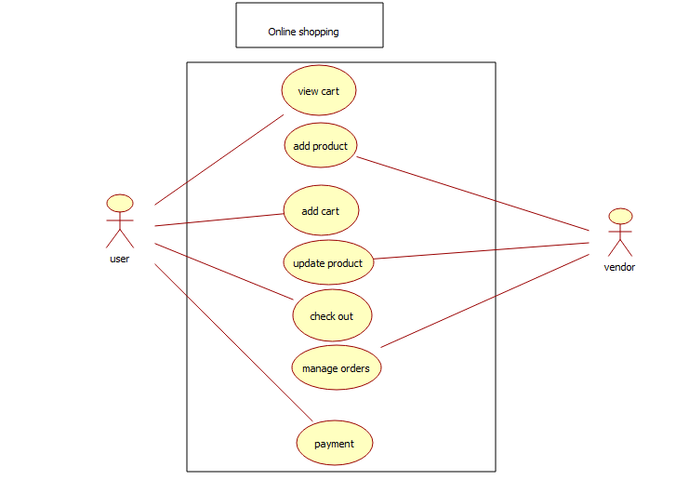
Result:
The Use Case Diagram illustrates how User and Vendor interact with the E-Commerce System for purchasing products.
3. Hospital Management System
Aim:
To model interactions between Doctor, Patient, and Receptionist in a Hospital Management System.
Algorithm:
- Start
- Patient registers at reception.
- Receptionist schedules appointment.
- Doctor examines patient.
- Doctor prescribes treatment or medicine.
- System stores patient records.
- Stop.
Input:
Patient details, Appointment request, Medical information.
Output:
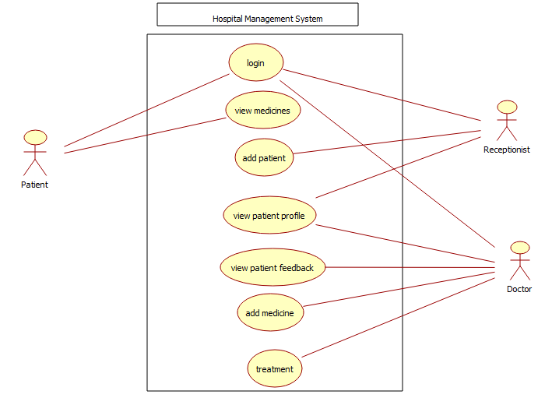
Result:
The Use Case Diagram represents interactions among Patient, Doctor, and Receptionist in hospital services.
4. Railway Reservation System
Aim:
To design a Use Case Diagram for ticket booking, cancellation, and checking ticket status in a Railway Reservation System.
Algorithm:
- Start
- User searches train availability.
- User books ticket if seats are available.
- System confirms booking.
- User may cancel ticket if needed.
- Ticket checker verifies ticket during travel.
- Stop.
Input:
Passenger details, Train number, Travel date.
Output:
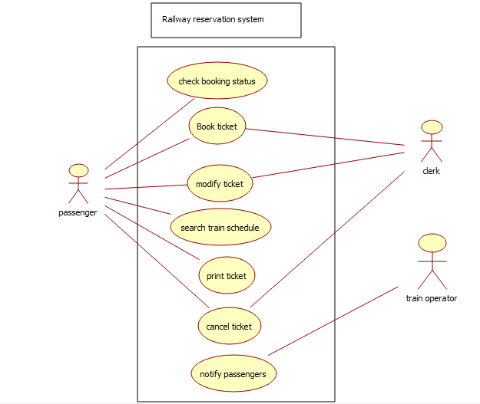
Result:
The Use Case Diagram shows interactions between Passenger, Ticket Checker, and Railway System.
5. Student Information System (SIS)
Aim:
To model interactions between Student, Teacher, and Administrator in a Student Information System.
Algorithm:
- Start
- Student logs into system.
- Student views courses and results.
- Teacher enters grades.
- Administrator manages student records.
- System updates database.
- Stop.
Input:
Student details, Course information, Marks entry.
Output:
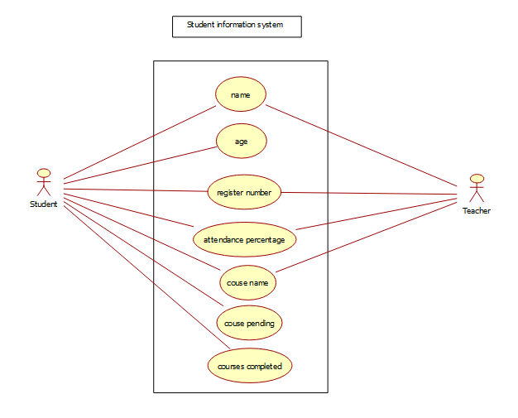
Result:
The Use Case Diagram represents interactions between Student, Teacher, Administrator, and the SIS.
6. University Management System
Aim:
To represent course registration, grade entry, and transcript generation using a Use Case Diagram.
Algorithm:
- Start
- Student registers for courses.
- Faculty enters grades.
- System calculates results.
- System generates transcript.
- Stop.
Input:
Student details, Course selection, Grade details.

Output:
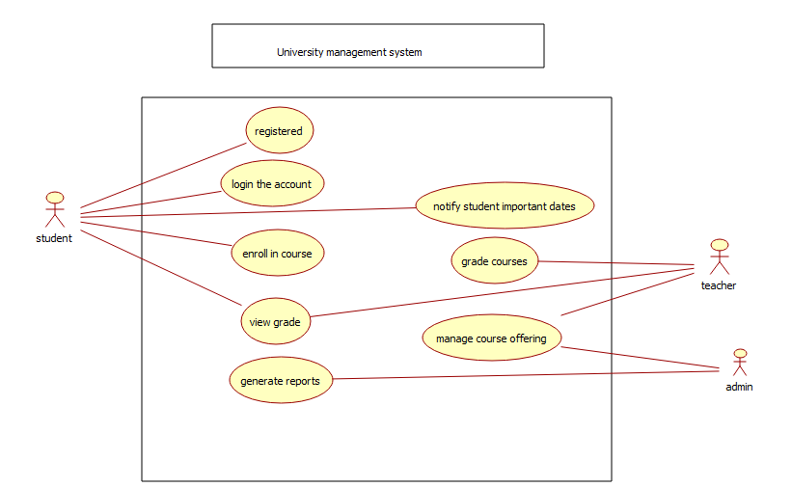
Result:
The Use Case Diagram shows interactions between Student, Faculty, and University System.
7. Employee Payroll System
Aim:
To model salary processing and employee management using a Use Case Diagram.
Algorithm:
- Start
- HR enters employee details.
- System calculates salary and deductions.
- Payroll is processed.
- Salary slip is generated.
- Stop.
Input:
Employee details, Attendance records, Salary structure.
Output:
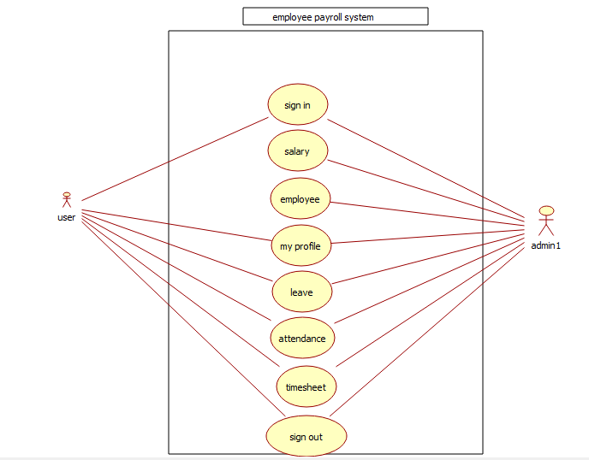
Result:
The Use Case Diagram illustrates interactions between Employee, HR/Admin, and Payroll System.

